### **CS23333-Object Oriented Programming Using Java**

**NAME: B. ELUMALAI**

**ROLL NO: 230701084**

# **Lab-04-Classes and Objects**

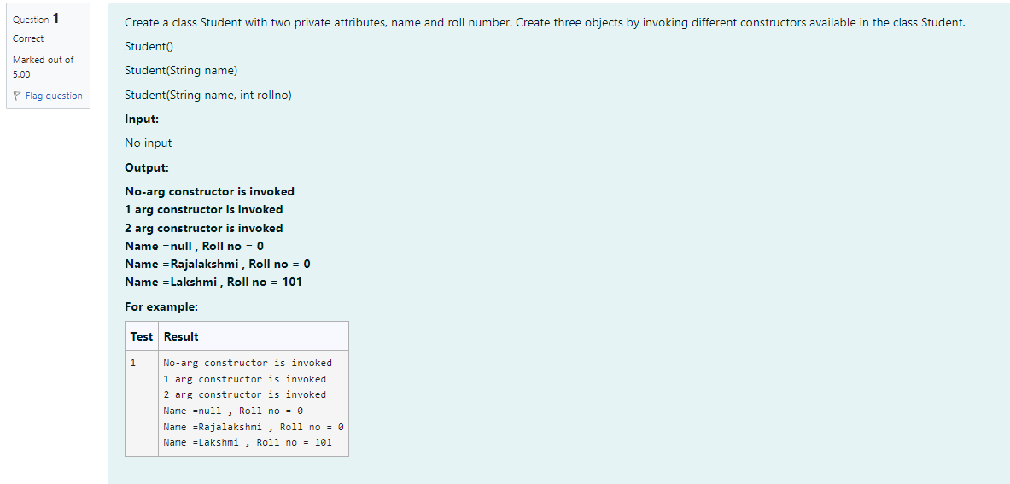

**CODE**

**class Student {**

**private String name;**

**private int rollNo;**

**public Student() {**

**System.out.println("No-arg constructor is invoked");**

**}**

**public Student(String name) {**

**System.out.println("1 arg constructor is invoked");**

**}**

**public Student(String name, int rollNo) {**

**System.out.println("2 arg constructor is invoked");**

**}**

**public void display() {**

**}**

**}**

**public class TestStudent {**

**public static void main(String[] args) {**

**Student student1 = new Student();**

**student1.display();**

**Student student2 = new Student("Rajalakshmi"); student2.display();**

**Student student3= new Student("Lakshmi", 101); student3.display();**

**System.out.println("Name=null, Roll no = 0");**

**System.out.println("Name Rajalakshmi Roll no=0");**

**System.out.println("NameLakshmi, Roll no 101");**

**}**

**}**

**OUTPUT**

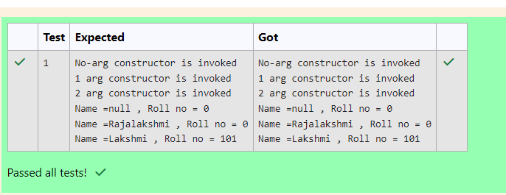

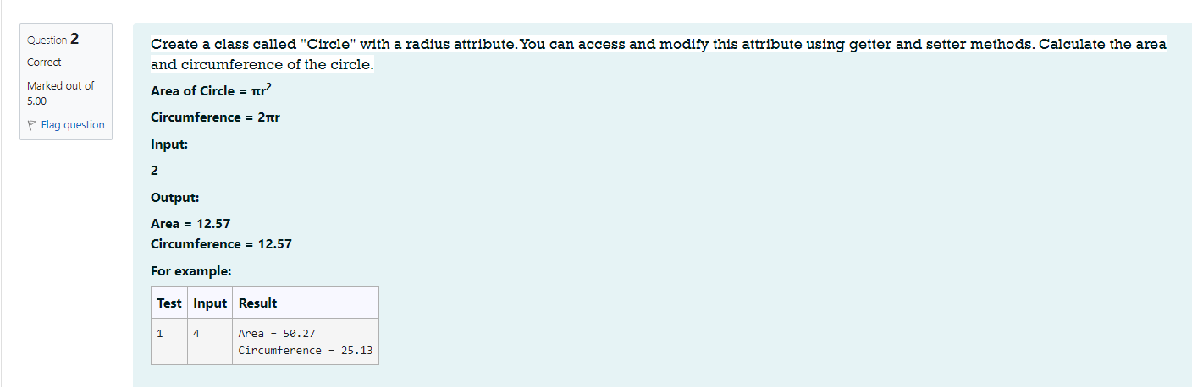

**CODE**

**import java.util.*;**

**public class Circle {**

**public static void main(String args[]){**

**Scanner a new Scanner (System.in);**

**int b=a.nextInt();**

**double area Math.PI* (b*b);**

**double cir-Math.PI*b*2;**

**System.out.printf("Area = %.2f%n", area);**

**System.out.printf("Circumference = %.2f%n", cir);**

**}**

**}**

**OUTPUT**

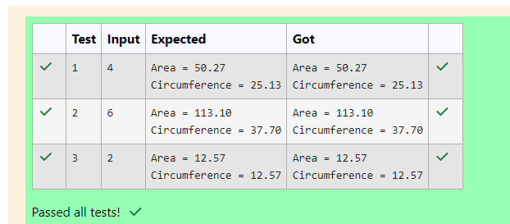

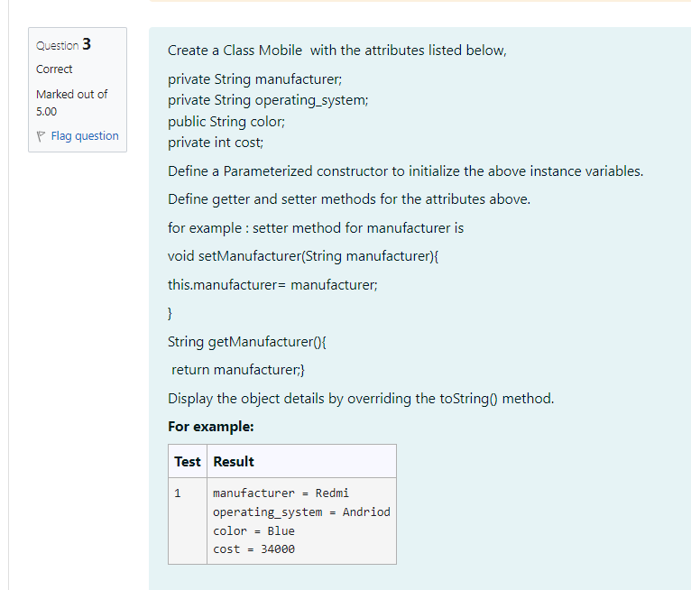

**CODE**

**public class Mobile {**

**private String manufacturer;**

**private String operatingSystem;**

**public String color;**

**private int cost;**

**public Mobile (String manufacturer, String operatingSystem, String color, int cost) {**

**this.manufacturer manufacturer;**

**this.operatingSystem operatingSystem;**

**this.color = color;**

**this.cost = cost;**

**}**

**public void setManufacturer (String manufacturer) {**

**this.manufacturer = manufacturer;**

**}**

**public String getManufacturer() {**

**return manufacturer;**

**}**

**public void setOperatingSystem (String operatingSystem) {**

**this.operatingSystem = operatingSystem;**

**}**

**public String getOperatingSystem() {**

**return operating System;**

**}**

**public void setColor(String color) {**

**this.color = color;**

**}**

**public String getColor() { return color;**

**}**

**public void setCost(int cost) {**

**this.cost = cost;**

**}**

**public int getCost() {**

**return cost;**

**}**

**@Override**

**public String toString() {**

**return "manufacturer = + manufacturer + "\noperating_system = "\ncolor = "+ color + "\ncost = + cost; + operatingSystem + "**

**}**

**public static void main(String[] args) {**

**Mobile mobile new Mobile("Redmi", "Andriod", "Blue", 34000); System.out.println(mobile);**

**}**

**}**

**OUTPUT**

